21.11.2022
Expert Study Visits to Poland under the EEA FM Project “Capacity building of key stakeholders in the area of geothermal energy”

Between 14 and 18 November 2022, Expert Study Visits to Poland were held under the EEA FM Project “Capacity building of key stakeholders in the area of geothermal energy” (acronym: KeyGeothermal). The Project is implemented by the Mineral and Energy Economy Research Institute of the Polish Academy of Sciences and the National Energy Authority of Iceland (keygeothermal.pl). The Study Visit experts group included Icelandic and Polish team members who are the Project partners.
Konin and Chochołów were selected as the visit sites due to their prospects for geothermal use in district heating. Miejskie Przedsiębiorstwo Energetyki Cieplnej [Municipal District Heating Company] from Konin and Chochołowskie Termy [Chochołowskie Thermal Baths] were the visit hosts.
A geothermal well was drilled in Konin a few years ago and now another one is being drilled (to make a doublet) while a geothermal heating plant is under construction. Nowadays, most heat supplied to the inhabitants of Konin is mostly generated by two biomass blocks of Konin Power Plant (PAK-PCE Biopaliwa i Wodór Sp. z o.o.) and in Zakład Termicznego Unieszkodliwiania Odpadów [Thermal Waste Neutralisation Facility], which is a part of Miejski Zakład Gospodarki Odpadami Komunalnymi [Municipal Waste Management Company] (MZGOK Sp. z o.o.). Soon, some heat supplied to end users will originate from the geothermal.
The Study Visit included meetings with the Mayor of Konin, the Board and managers of MPEC-Konin Ltd. (Municipal District Heating Company), representatives of companies involved in the geothermal project, and learning more (on site) about the geothermal wells and the geothermal heat plant under construction, facilities of the Municipal Waste Management Company, and Konin Power Plant’s systems (biomass units).
As a result of the Study Visits, proposals and recommendations will be elaborated on some operation, technology and energy solutions for the geothermal project implemented in Konin. They will be developed by the Icelandic and Polish experts – the “KeyGeothermal” Project partners – in collaboration with specialists from MPEC-Konin and other entities.
Chochołowskie Thermal Baths have been operating in Chochołów for a few years now. Their operations are based on geothermal water with very good parameters, produced by the Chochołów PIG-1 well drilled at the turn of the 1980s and 1990s. Similarly to Konin, the second well is being drilled.
The Study Visit included meetings with the Chochołowskie Thermal Baths Board and staff, local governments representatives and members of the team implementing the “Hydro-Geo-Solar” Project financed from EEA FM and Norway Grants (Chochołowskie Thermal Baths are the Project’s beneficiary). The participants learned more about the Thermal Baths’ facilities and systems, learned about the parameters of geothermal well in operation and the drilling of the new well.
Chochołowskie Thermal Baths propose broader use of the geothermal water’s energy potential, e.g. for local district heating purposes. This would help reduce air pollution, to improve the inhabitants’ life quality and well-being of numerous tourists visiting the site, stabilise the heat prices, etc. The estimates, proposals and recommendations developed by the Project experts in collaboration with Chochołowskie Thermal Baths and local government representatives shall be helpful in determining the scale and method of the implementation mentioned above.

The proposals and recommendations from the Expert Study Visits to Konin and Chochołów will be included in the Report that is expected to be developed in the coming months. It shall include the knowledge, experiences and technologies proven in Iceland – the Donor State, and the Polish stakeholder’s experiences and proposals.
The next round of Expert Study Visits to Poland under the “KeyGeothermal” EEA Project is scheduled for 2023.
The Project partners would like to thank all individuals and institutions for their collaboration in planning and organising the Expert Study Visits to Poland – in Konin and Chochołów. Successful Visits are the results of this good collaboration and engagement of many persons.
The photos taken during the event are published under the text.

The Expert Study Visits to Poland were another action taken under the EEA FM Project “Capacity building of key stakeholders in the area of geothermal energy”. The previous ones included Training in Poland in May 2022 and a Study Visit to Iceland in September 2022.
Beata Kępińska, Aleksandra Kasztelewicz, Maciej Miecznik (MEERI PAS)
Baldur Petursson (NEA)
The Project “Capacity building of key stakeholders in the area of geothermal energy” is financed by the European Economic Area Financial Mechanism 2014-2021 under the “Environment, Energy and Climate Change” Programme, “Energy” Programme Area.

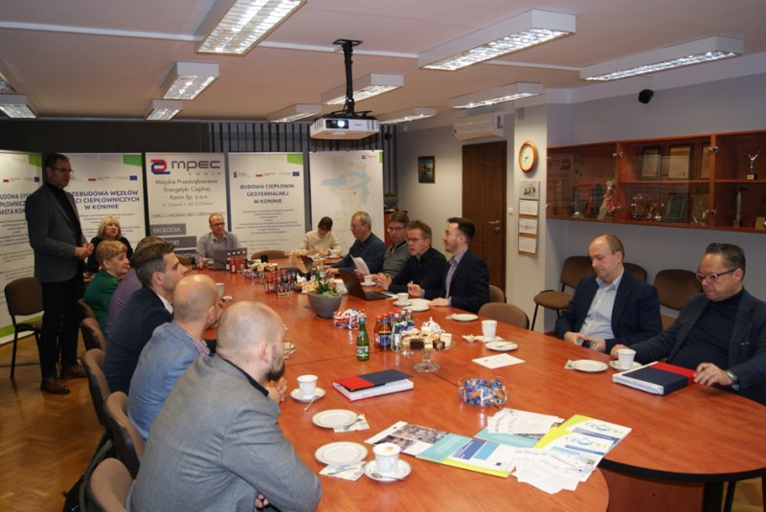
Working meeting in the head office of the Municipal District Heating Company (MPEC) in Konin (Photo: MPEC Konin)
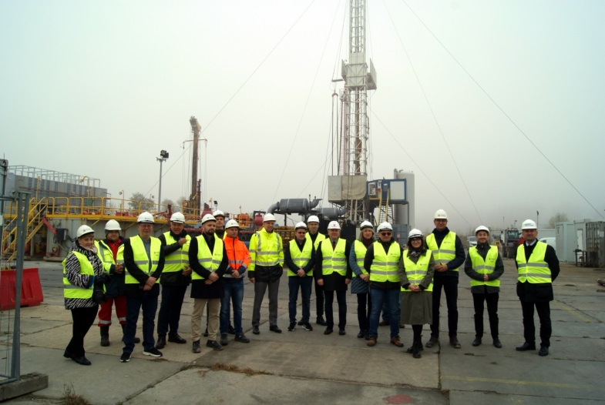
Study Visit’s participants in the field with the Konin GT-1 and Konin GT-3 (being drilled) wells (Photo: MPEC-Konin)
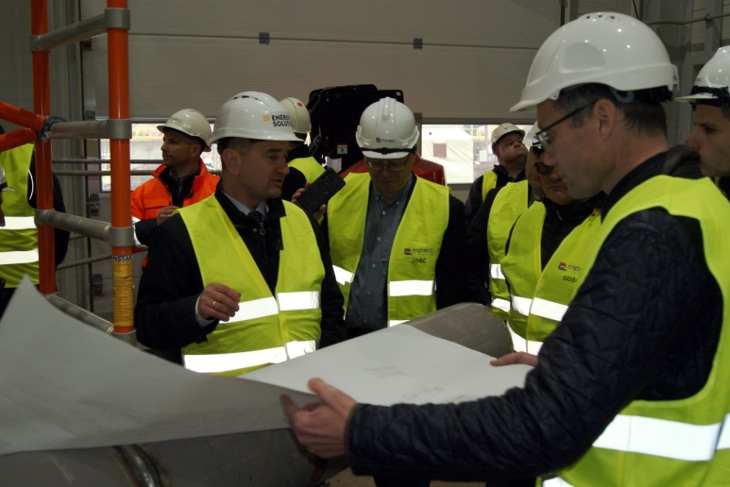
Inside the geothermal heating plant under construction in Konin (Photo: MPEC-Konin)
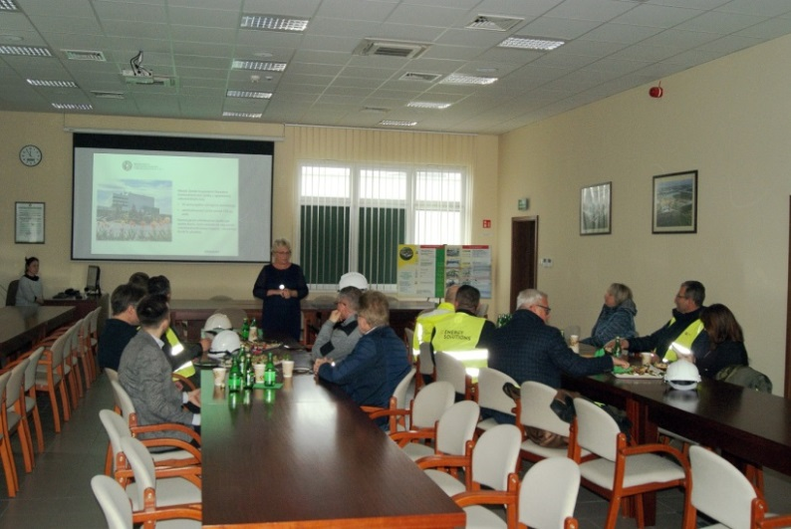
In the Municipal Waste Management Company - MZGOK Sp. z o.o. (Photo: MPEC-Konin)

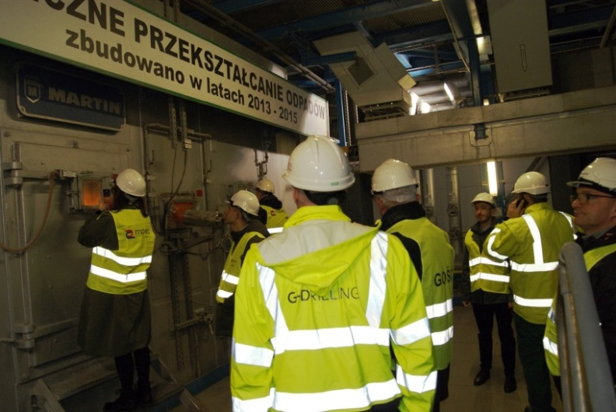
In the Thermal Waste Neutralisation Facility. MZGOK Sp. z o.o. (Photo: MPEC-Konin)
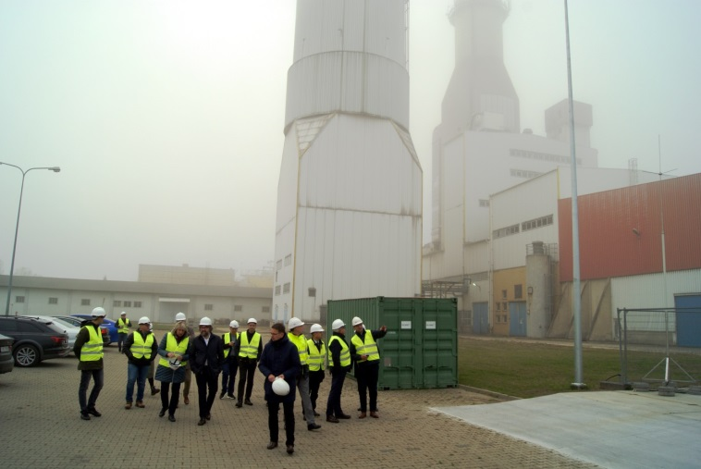
In the premises of the Konin Power Plant (Photo: MPEC-Konin)
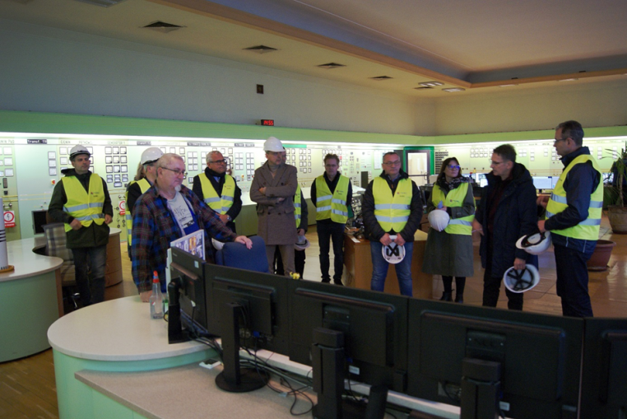
In the dispatch room of the Konin Power Plant (Photo: MPEC-Konin)
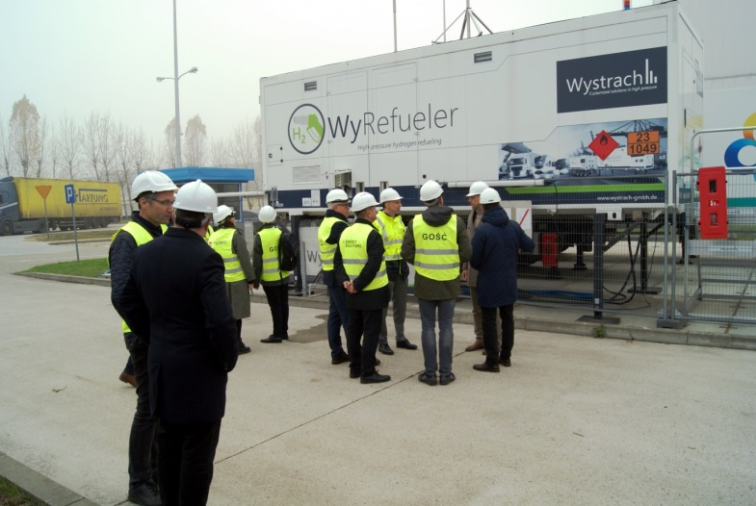
Hydrogen charging station for a fuel-cell municipal bus. Premises of the Konin Power Plant
(Photo: MPEC-Konin)
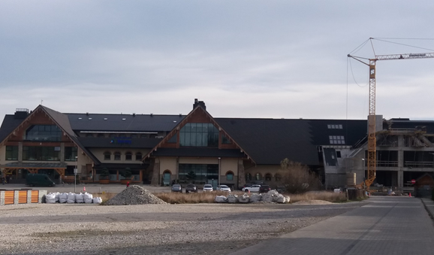
Chochołowskie Thermal Baths - general view from the west (Photo: B. Kępińska)
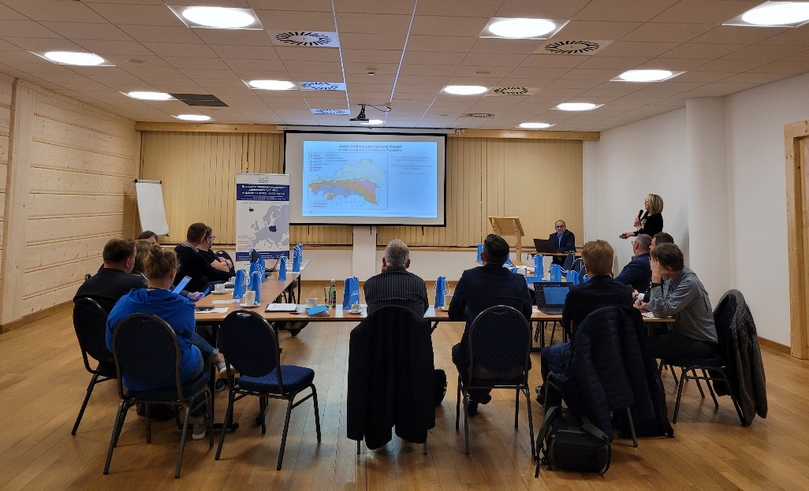
Working meeting in the head office of Chochołowskie Thermal Baths (Photo: A. Kasztelewicz)
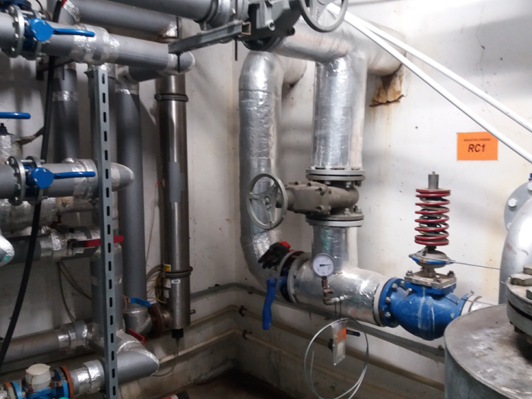
Part of the system supplying geothermal water from the Chochołów IG-1 well to Chochołowskie Thermal Baths (Photo: B. Kępińska)
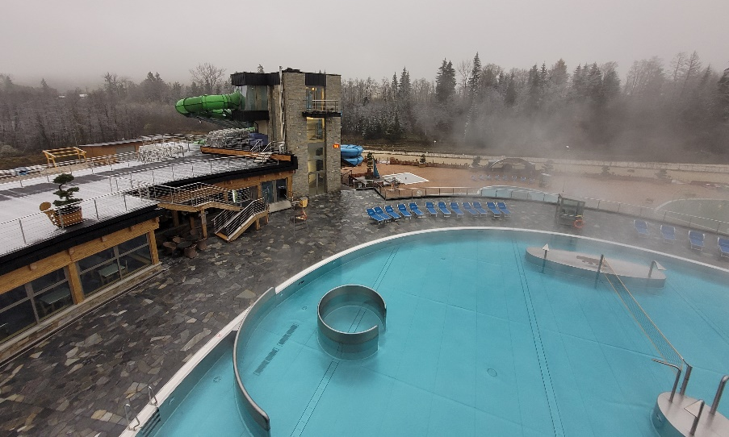
A part of Chochołowskie Thermal Baths (Photo: A. Kasztelewicz)
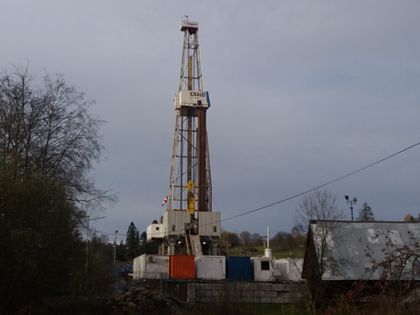
Drilling rig and the rig’s area of the Chochołów GT-1 well (Photo: B. Kępińska)
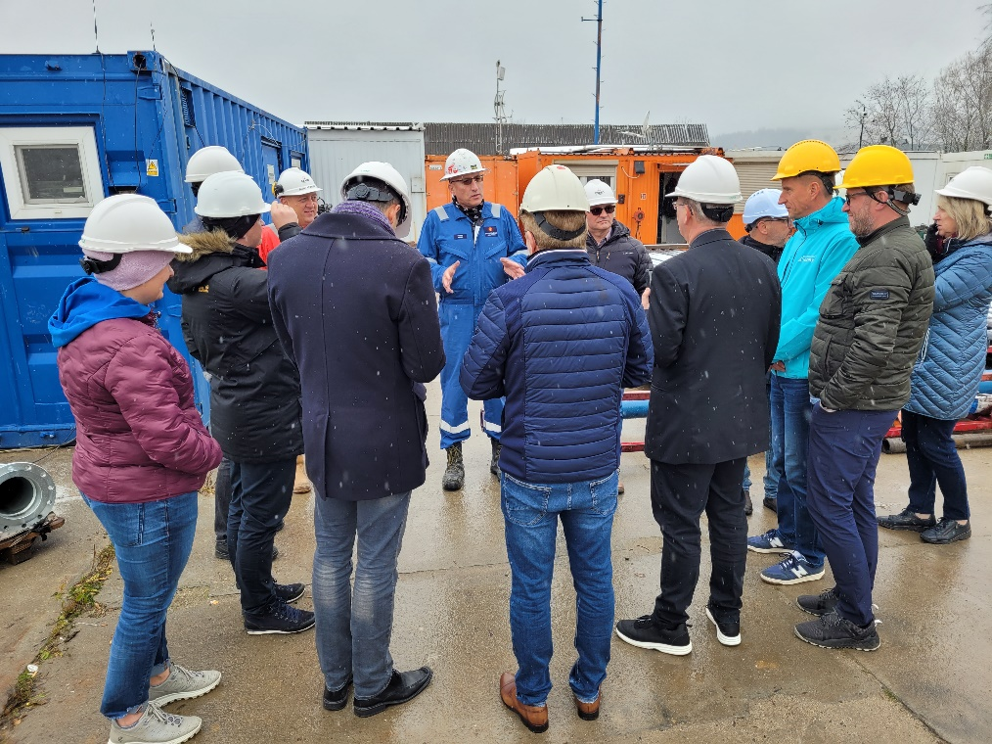
Visit to the Chochołów GT-1 well’s drilling rig (Photo: A. Kasztelewicz)
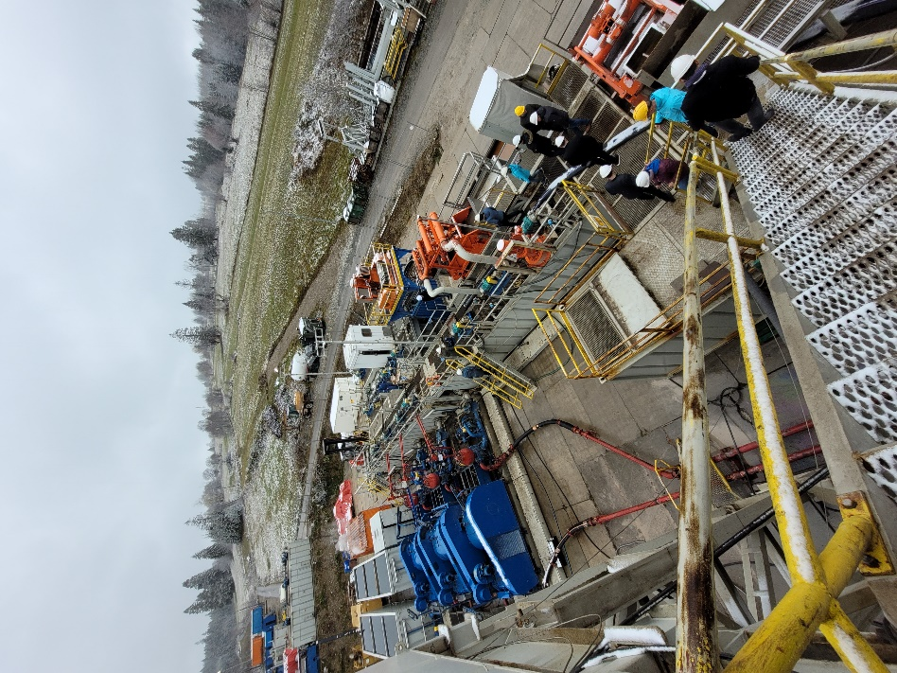
Visit to the Chochołów GT-1 well’s drilling rig (Photo: A. Kasztelewicz)

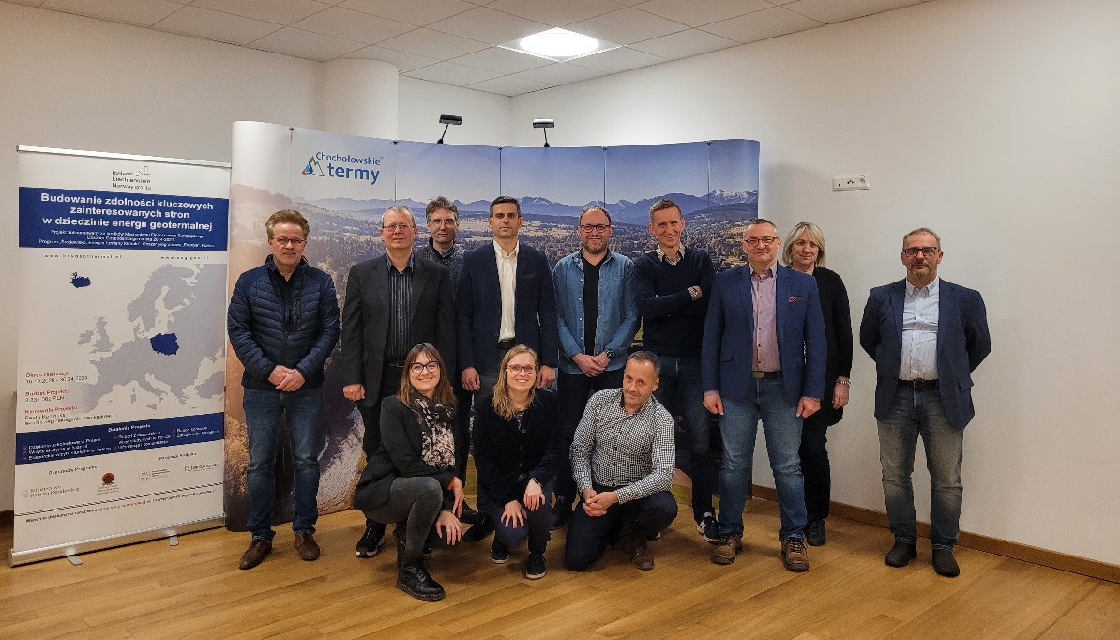
Participants of the Study Visit to Chochołowskie Thermal Baths (Photo: A. Kasztelewicz)

