The FM EEA Project “Capacity building of the key stakeholders in the area of geothermal energy” on the agenda during significant national and international events
Our Project was presented during two significant Polish and European sectoral events
held in October 2022.
The 35th Conference „Energy and energy sources in the domestic economy – Energy security hazards for Poland and EU” in Kościelisko near Zakopane (9-12 October 2022). The Conference was organised by the MEERI PAS and attracted nearly 190 participants. We presented a roll-up with the project information as well as a lecture and poster entitled „Good practices and training towards successful development of geothermal heating in Poland - Polish-Icelandic collaboration” (authors: B. Kępińska, A. Kasztelewicz, M. Miecznik, W. Bujakowski, B. Bielec, L. Pająk, B. Tomaszewska, B. Petursson). Our lecture’s abstract was included in the conference materials. All Conference participants received the Project leaflets.
Find out more about the Conference at: https://se.min-pan.krakow.pl/nastepna.php
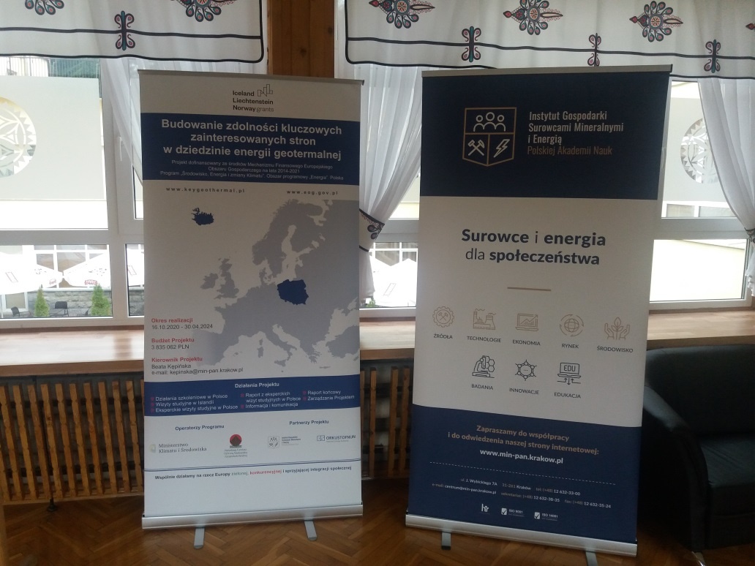
Roll-up with the Project information in the centre of the poster session room. Photo: B. Kępińska
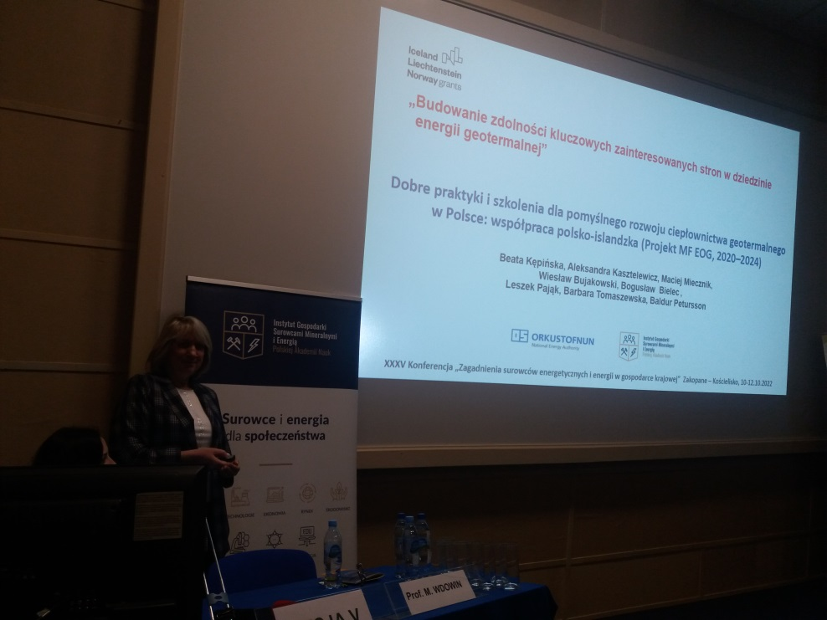
Delivering the lecture entitled „Good practices and training towards successful development of geothermal heating in Poland - Polish-Icelandic collaboration”. Photo: Z. Grudziński
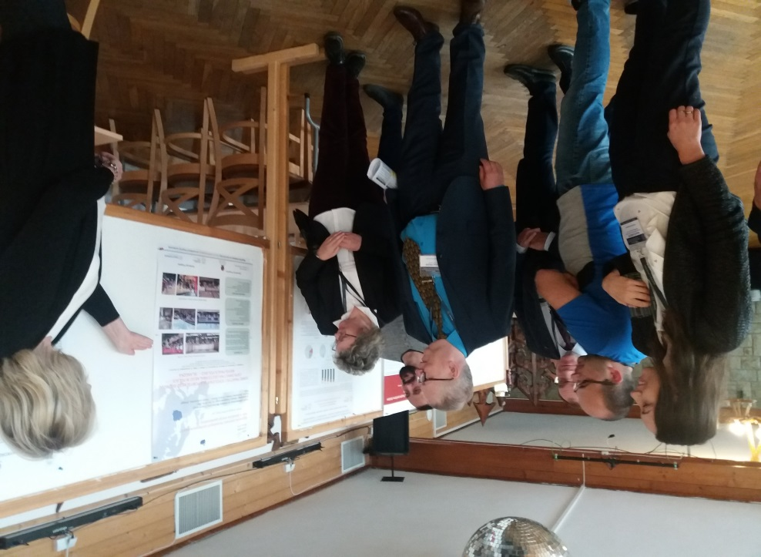
Presentation of the poster entitled „Good practices and training towards successful development of geothermal heating in Poland - Polish-Icelandic collaboration”. Photo: Z. Grudziński

European Geothermal Congress 2022, Berlin (Germany), 17-22.10.2022
The European Geothermal Congress was organised by the European Geothermal Energy Council (EGEC) and the German Geothermal Association (BVG). It was attended by about 1,300 participants and several dozen exhibitors from forty-five countries.
The Congress was held under the slogan of the Geothermal Decade (#GeothermalDecade), during which the role of geothermal in energy security and green transformation shall be a priority at national and EU levels.
The Congress participants also pointed out that REHeatUE should be used in parallel with the slogan "RePowerUE", because the heating sector represents over 40% of energy demand in Europe, and geothermal energy has the potential to significantly contribute to meeting this demand, including in district heating. These suggestions and opinions confirmed once again the importance of actions undertaken consistently for several years by the Polish government, as well as the importance of the FM EEA Project KeyGeothermal implemented by MEERI PAS (Poland) and NEA (Iceland) teams, aimed at raising awareness and knowledge about the technologies and benefits of geothermal district heating.
Piotr Dziadzio, Under Secretary of State in the Ministry of Climate and Environment of Poland, the Chief Geologist of Poland attended the opening session of the Congress and presented the activities undertaken by the Ministry and Polish Government towards developing the use of geothermal energy in Poland, including but not limited to financing schemes of investment projects aimed to manage geothermal heating resources in Poland. Our Project supports the activities mentioned above.
During a Congress technical session, a presentation was delivered on “Building the awareness and public acceptance of geothermal uses among key stakeholders in Poland (the EEA FM Project, 2014–2021)” authored by Beata Kępińska, Aleksandra Kasztelewicz, Maciej Miecznik, Baldur Petursson, and Jon Gudmundsson.
An extended abstract of that presentation was included in the conference materials.
At the end of EGC2022 the "Call for action" was prepared, addressed to decision-makers at various levels, including the governments, and the EU-institutions in order to take the fastest possible action for financial and regulatory support for geothermal energy, which can significantly help contribute to easing the energy crisis in Europe, especially in the heating sector (as the only RES available without restrictions all year round), increase energy independence and limit price increases. As intended by the initiators of the Call for action, it should be forwarded to policy makers, national governments and EU bodies. "Call for action" is at the end of this information.
Find out more about the Congress at: https://europeangeothermalcongress.eu/

European Geothermal Congress 2022 – Call for action.
Geothermal must be the core of the energy transition

The participants of the European Geothermal Congress 2022 held on 17-22 October 2022 in Berlin, Germany, call for fast and effective action to accelerate the geothermal energy development in Europe.
Geothermal is the only local renewable source of baseload heating, cooling and electricity available everywhere, all the time.
The entire geothermal value-chain calls on governments and regulators to empower the industry to invest at the scale required to address the current energy supply and price emergency, climate crisis and economic malaise.
To do this, we need:
- Clear political acknowledgement of the many benefits from geothermal;
- Dedicated and sufficient funding streams;
- Support for local authorities to plan heat network transitions; and a
- European-wide financial risk mitigation framework.

The European Geothermal Congress 2022 was the largest gathering ever including, over 1220 companies and experts from over 45 nations!
We need action and we need it now.
Source: EGC2022 and EGEC materials

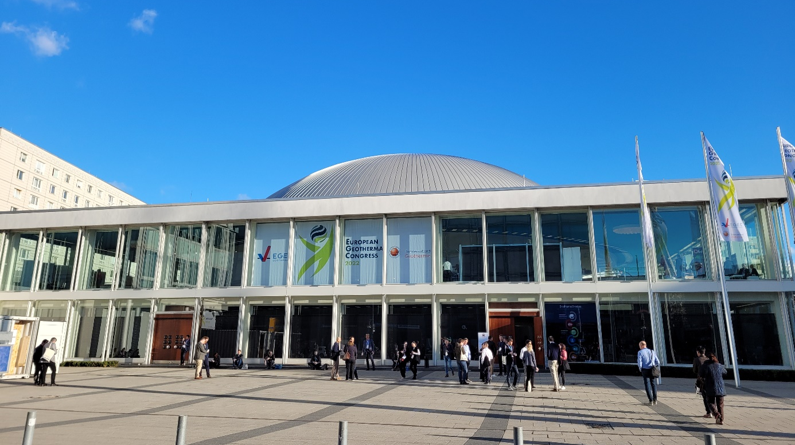
Facade of the Berlin Congress Centre hosting the EGC2022. Photo: A. Kasztelewicz
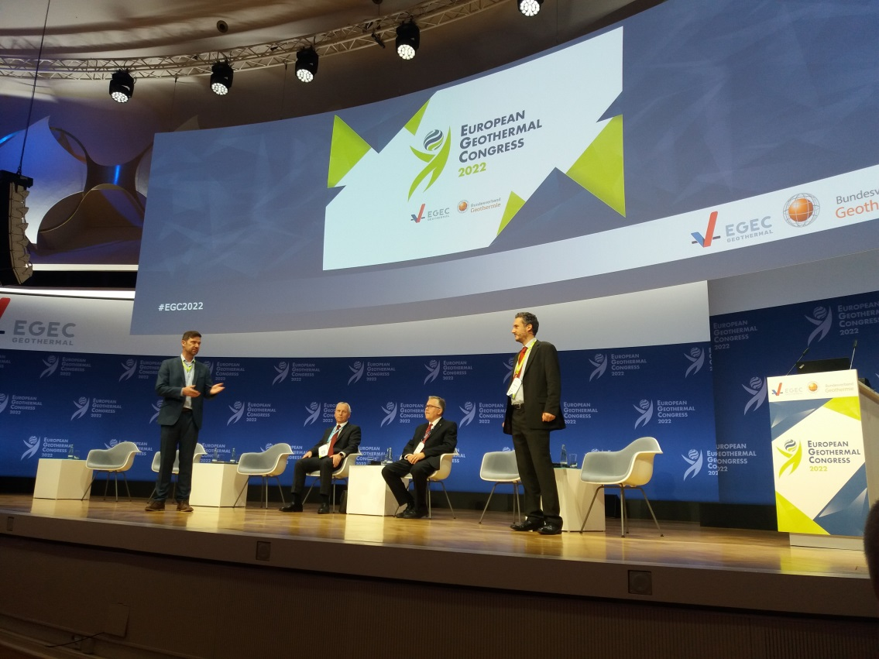
Opening of the EGC2022. From the left: Andre Deinhardt (Secretary General of BVG), Helge-Uve Braun (President of BVG), Miklos Antics (President of EGEC), Philippe Dumas (Executive Director of EGEC). Photo: B. Kępińska
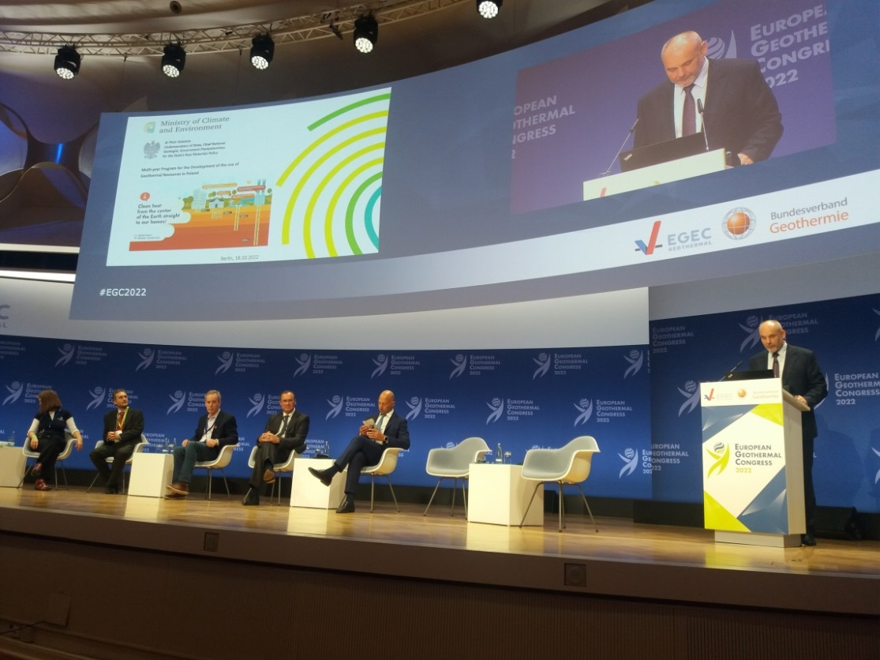
Presentation delivered by Minister Piotr Dziadzio during the EGC2022’s opening session.
Photo: B. Kępińska
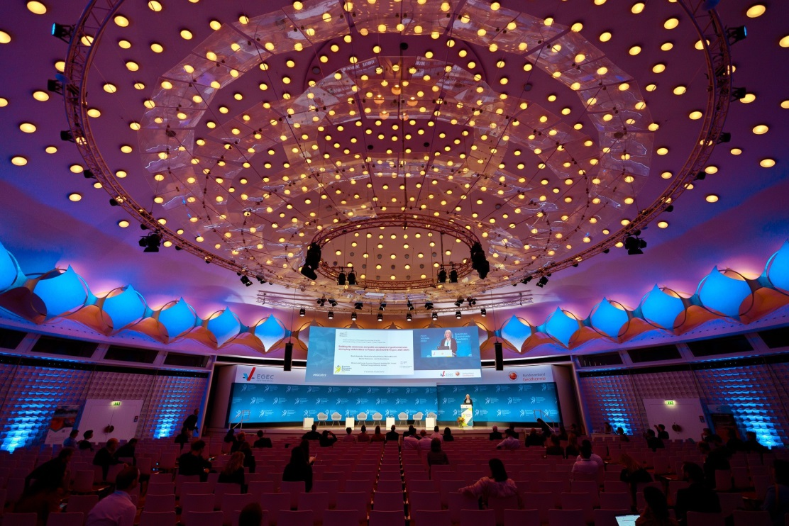
Delivering the lecture entitled „Building the awareness and public acceptance of geothermal uses among key stakeholders in Poland (the EEA FM Project, 2020–2024)”. Photo: GEORG
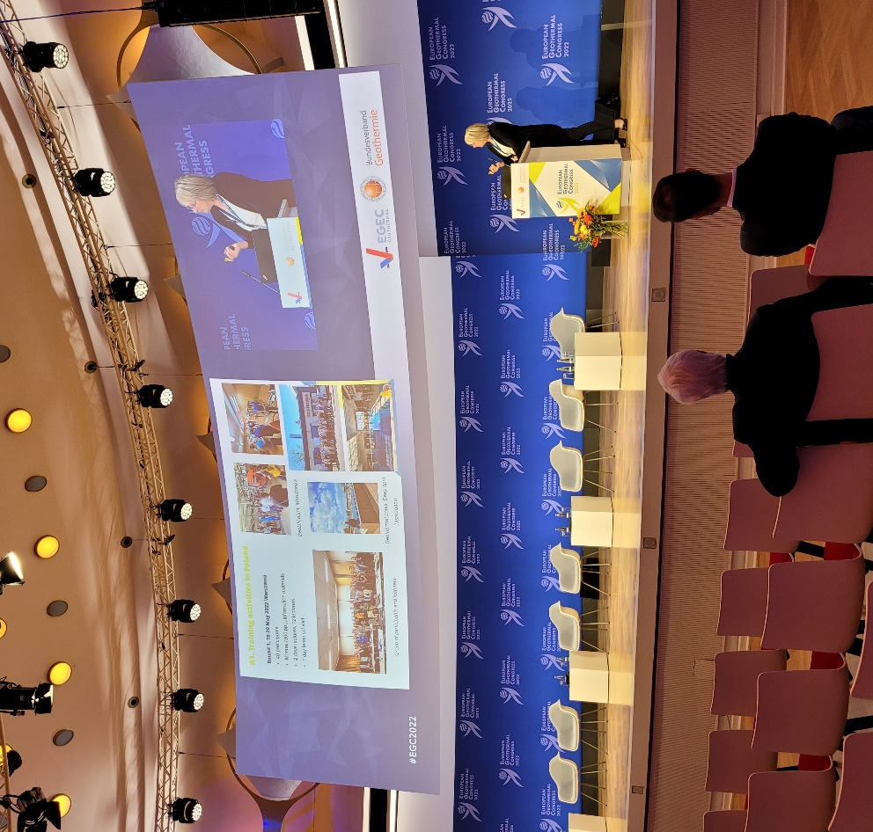
Beata Kępińska presenting the Project. Photo: A. Kasztelewicz

