Geothermal energy: Study visit to Iceland under the project called “Capacity building of key stakeholders in the area of geothermal energy”, 26 – 30 September 2022.

A study visit to Iceland was organised between 26 and 30 September 2022 under the project called “Capacity building of key stakeholders in the area of geothermal energy”. It is among the three predefined projects financed by the Financial Mechanism of the European Economic Area in the Environment, Energy and Climate Change Programme, 2014–2021, Energy programme area. It is executed by the Mineral and Energy Economy Research Institute of the Polish Academy of Sciences (MEERI PAS) and the National Energy Authority (NEA) of Iceland. The Project lasts from October 2020 until April 2024 (www.keygeothermal.pl).
The Project aims to build the capacity of key stakeholders in the area of geothermal energy by improving their skills and knowledge of the use of geothermal resources, including but not limited to low-emission heating. The Project will contribute to fulfilling the objectives of the Programme mentioned above, including developing geothermal use in Poland by supporting other activities in this area, e.g. investments executed owing to governmental support schemes implemented in recent years. The Project stakeholders include representatives of different administration levels, local governments, operators of existing and investors of intended geothermal heating plants, beneficiaries of government support programmes, geological administration bodies, scientific research organisations, service providers, consultants, and other entities in the geothermal sector. Learning good practices in geothermal district heating and other geothermal applications in Iceland, aspects related to the state’s role, modern management, economics and energy efficiency in Iceland were the focal point of the visit held in September 2022.
The Study Visit was preceded by Training activities in Poland between 18 and 20 May 2022 (information available at: www.keygeothermal.pl). The Study Visit was prepared by the NEA’s team in collaboration with MEERI PAS.
Twenty-nine participants from Poland took part in the study visit. They represented local governments and district heating companies – beneficiaries of government programmes supporting geothermal use in Poland; power companies interested in adding geothermal district heating and other geothermal applications to their portfolio; state geological bodies, scientific institutions, and the Ministry of Climate and Environment.
The study visit began with an introductory Seminar on 27 September (over seventy participants) opened by Halla Hrund Logadóttir – General Director of the National Energy Agency of Iceland. The honorary guests at the Seminar included Guðlaugur Þór Þórðarson – The Minister of Environment, Energy and Climate of Iceland, a representative of Þórdís Kolbrún R. Gylfadóttir – the Minister of Foreign Affairs of Iceland and Gerard Pokruszyński – Polish Ambassador to Iceland. They delivered special addresses highlighting unprecedented global circumstances triggered by the Russian Federation’s military attack on Ukraine and the resulting multiple crises, including the energy crisis. The speakers indicated the need to maximise the use of local energy resources, e.g. geothermal energy. They emphasised the role of international cooperation in this area, including cooperation between Iceland and Poland. The same was highlighted by Poland’s representatives: Adam Guibourgé-Czetwertyński – Undersecretary of State in the Ministry of Climate and Environment (in his letter addressed to the Study Visit’s participants), and the Ambassador, Gerard Pokruszyński (who has been promoting geothermal for many years as one of the critical areas of Polish-Icelandic collaboration and supporting activities in this area). The Seminar’s agenda included an overview of the state of geothermal use in Iceland and Poland, with a particular focus on both countries’ geothermal district heating solutions, policies and strategies in the 2040-2050 horizon.
The match-making session was highly popular among the Seminar participants and attracted representatives of over thirty entities from both countries. It included presentations of Polish and Icelandic companies and institutions interested in cooperation and establishing direct contacts in the area of district heating and other uses of geothermal energy.
The second and third day (28 and 29 September) of the very busy stay in Iceland covered visits to selected geothermal facilities, including heat plants (in Reykjavik and several localities in the south of Iceland) which operate based on geothermal waters with parameters similar to those observed in many Polish places. The participants learned about the management, practical use and billing of energy consumption by end users. Different methods were presented of geothermal water, steam and energy use in cogeneration plants in the south of Iceland – in Hellisheidi and Svartsengi, including a number of innovative methods and projects implemented in geothermal resource parks whose centres are located in the cogeneration plants. In another town, the participants visited a cogeneration (ORC) plant relevant to the geothermal water parameters in some places in Poland. Moreover, they learned about successful research and works, e.g. on carbon dioxide reinjection and storage in the rock mass (stored permanently in a solid form) carried out for several years now and about alternative fuel production. Many of these applications and energy cluster experiences can be implemented in Poland. The participants received information materials helpful during and after the Study Visit.
Some time was left during the Study Visit to discover geothermal, natural and historical attractions of Iceland – geysers, Gullfoss waterfall, Thingvellir rift valley (where Iceland’s statehood and parliamentarism originated from), enjoy geothermal pools, admire the Northern Lights, and take a walk around Reykjavik which is the northernmost capital in the world and also the cleanest one, as it is nearly entirely heated with geothermal energy (the first geothermal heating systems were built in the 1930s).
Many participants positively evaluated the organisation and content of the Study Visit. It was ensured through the agenda selected to consider the geothermal conditions and district heating perspectives in Poland, meet the participants’ expectations and needs, as well as thanks to active participation and high interest in all topics discussed and visited geothermal facilities, discussions, conversations and friendly and welcoming atmosphere which we owe to the participants and organisers. The professional services of two interpreters significantly contributed to a full understanding of the content and comfort of the participants. Even though it does not testify to the organisers’ humbleness, they would like to quote an anonymous opinion of a Study Visit participant:[…] This has been the best-prepared study visit I have ever participated in. It was well conceived and suited to the participants’ needs […]
The Study Visit fulfilled the set objectives, and it will undoubtedly translate into specific effects for many participants, their companies and institutions. It proved (similarly to the previous Training activities in Poland in May 2022) that Polish stakeholders need such activities as well as the opportunity to use the expertise in district heating and other methods of geothermal use, especially from the global leaders in this area. Geysers and geothermal steam are not the only resources in Iceland – the temperatures of Icelandic geothermal water are similar to those in Poland; geothermal water is commonly used in district heating and other areas. The Study Visit participants saw it for themselves, learnt the arguments and were encouraged to similar geothermal applications in Poland, especially in light of the current challenges we face.
The Study Visit provided the opportunity to exchange experiences and information between the Polish and Icelandic stakeholders on geothermal district heating and other geothermal applications, harness the power of collaboration and contacts, which is among the key objectives of the EEA FM Programme under which the KeyGeothermal Project is executed and the reference Study Visit was organised.
The second Study Visit to Iceland is scheduled for 2023. It shall be preceded by the second round of Training activities in Poland in the middle of 2023.
The Project Partners would like to thank all people and institutions for their involvement in organising the Study Visit, developing the agenda, information materials and logistic aspects. They extend their thanks to the participants for the excellent atmosphere and much positive feedback on the Study Visit. Its successful execution resulted from good cooperation and many people's engagement.

Photos taken during the event are shown under the text.

Beata Kępińska, Aleksandra Kasztelewicz (MEERI PAS, Poland),
Baldur Petursson, Sólveig Skaftadóttir (NEA/ Orkustofnun, Iceland)

Find out more about the Project at www. keygeothermal.pl

The “Capacity building of key stakeholders in the area of geothermal energy” project is financed by the European Economic Area Financial Mechanism in the Environment, Energy, Climate Change Programme, 2014–2021, Energy programme area.

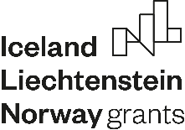

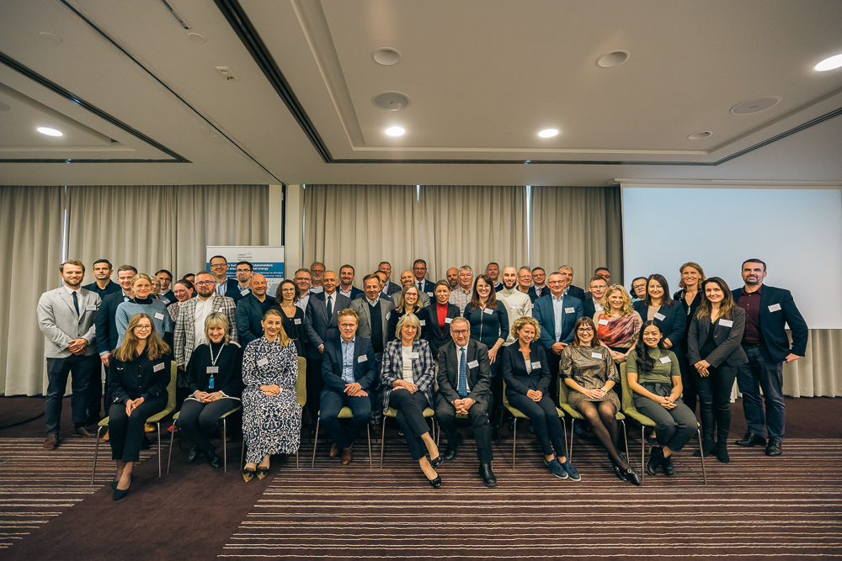
A group of participants of the Seminar opening the Study Visit to Iceland (photo: NEA files)
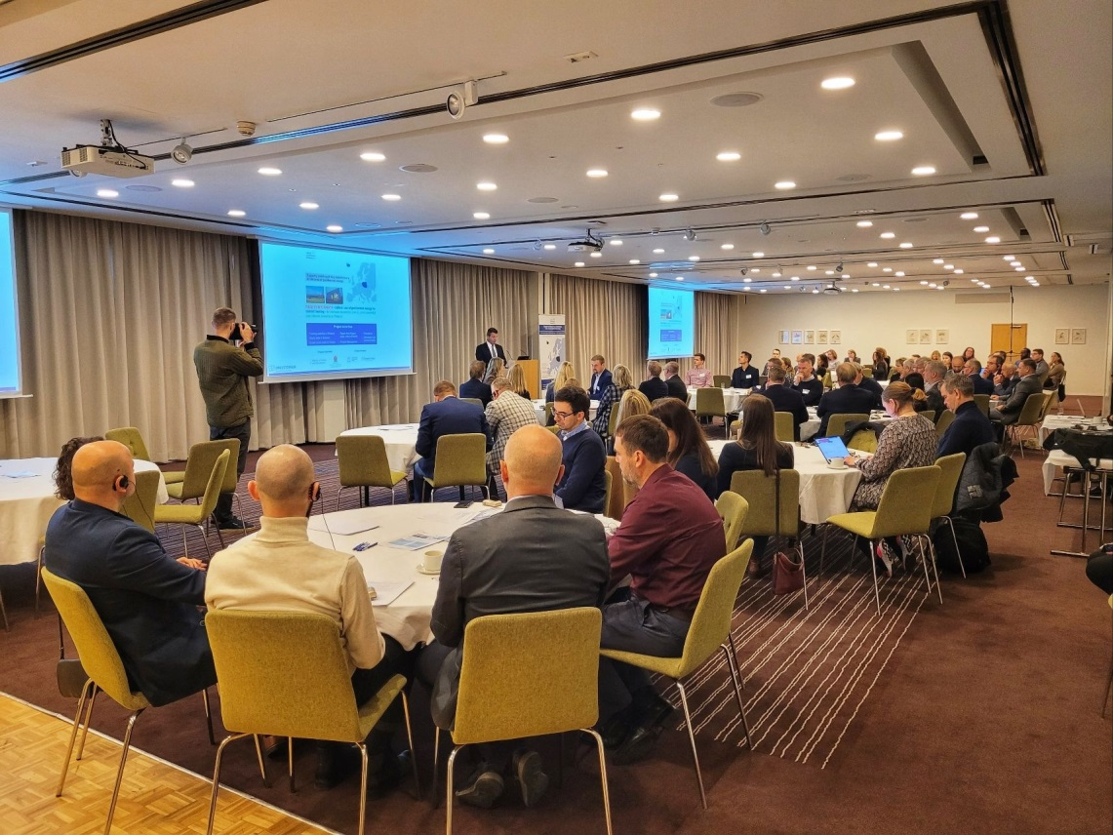
A session in the Seminar opening the Study Visit. Presentation delivered by the Minister of Environment, Energy and Climate of Iceland (photo: A. Kasztelewicz)
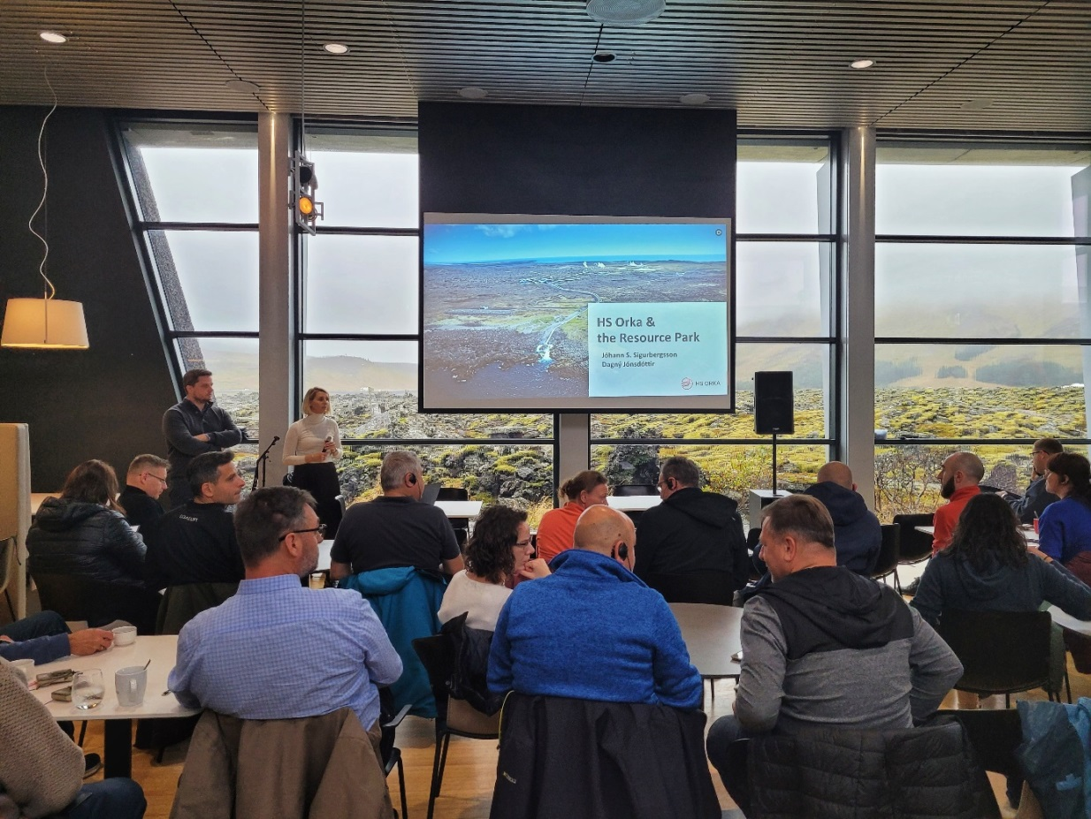
Visit Svartsengi geothermal power plant and resource park – introduction
(photo: A. Kasztelewicz)
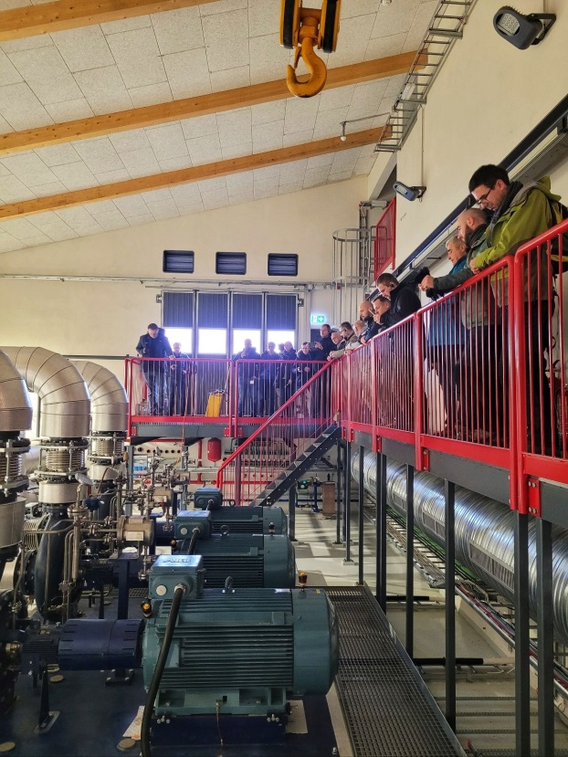
Visit to a geothermal heat plant in Selfoss (photo: A. Kasztelewicz)
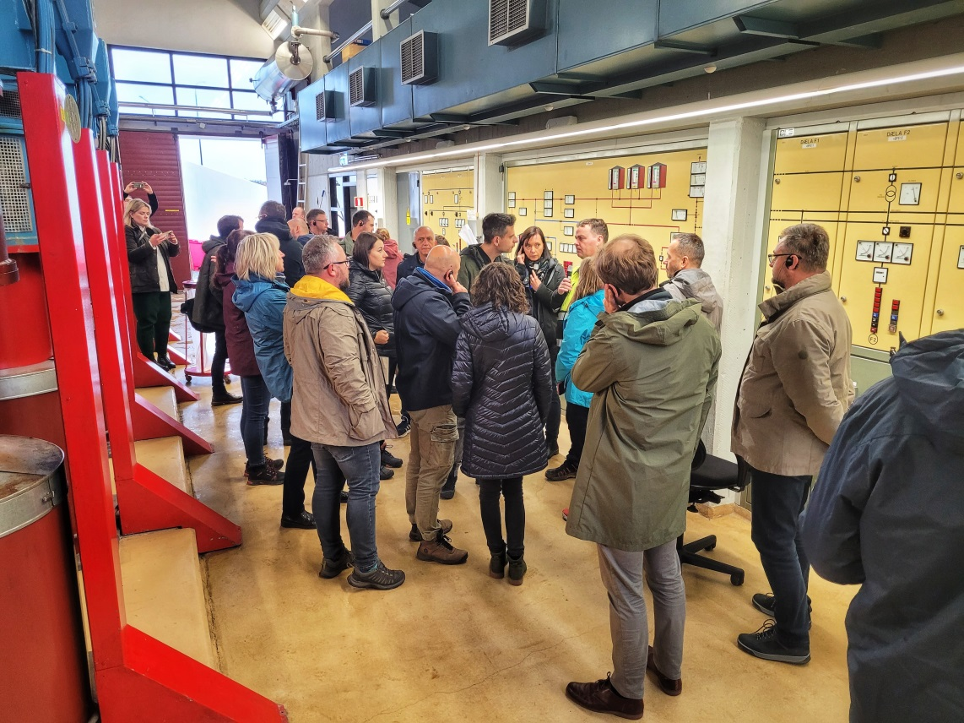
Visit to a geothermal district heating facility in the Reykjavik region (photo: A. Kasztelewicz)
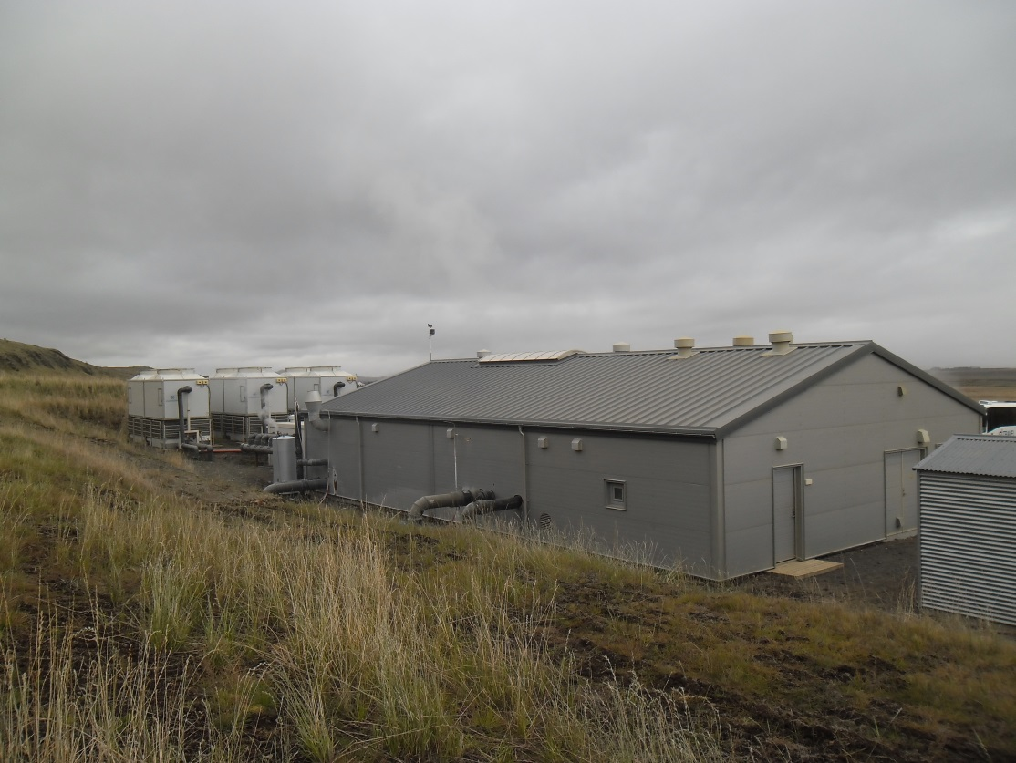
General view of a geothermal cogeneration facility (ORC) in Fludir (photo: B. Kępińska)

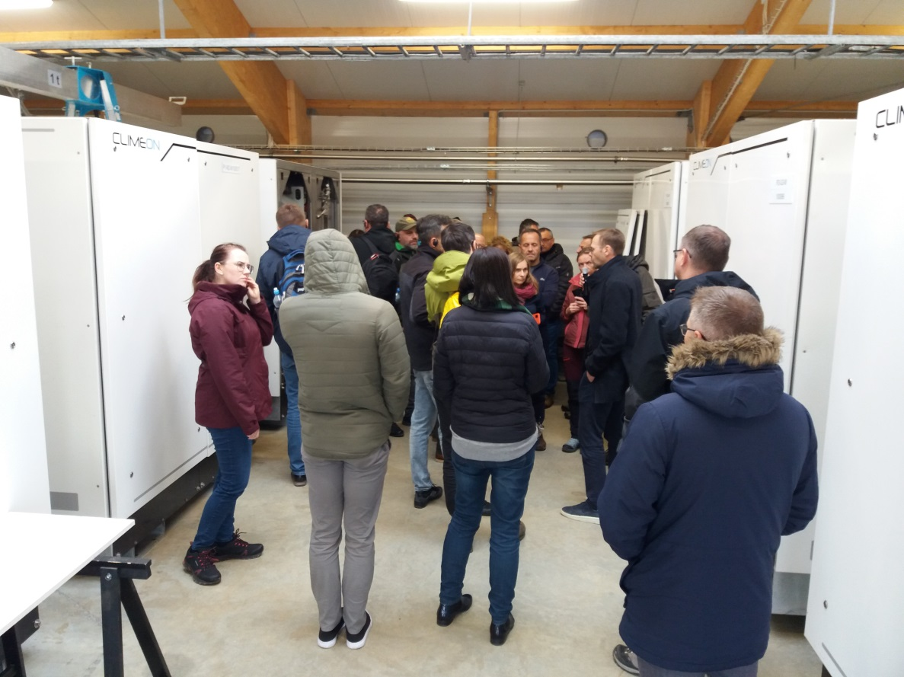
Inside a container comprising the essential components of a cogeneration system (ORC) in Fludir (photo: B. Kępińska)
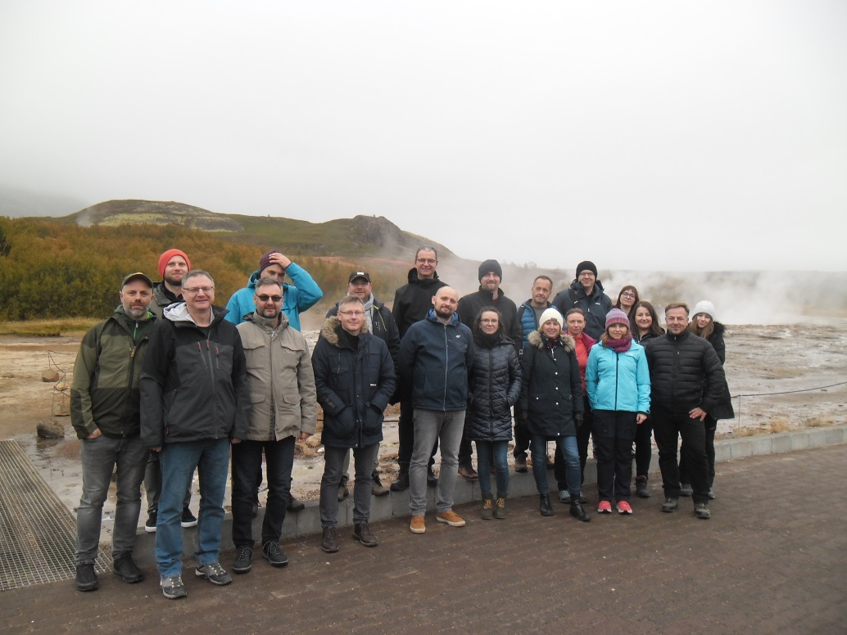
A group of the Study Visit participants at the Strokkur geyser (photo: B. Kępińska)

