Press release
June 2022

Seminar on training activities in Poland for optimal use of geothermal energy for district heating – to increase economic, social, environmental and climate benefits

Training activities in Poland for optimal use of geothermal energy for district heating to increase economic, social, environmental and climate benefits, was held in Poland 18th to 20th of May 2022.
The training activities were one part of the EEA FM project 'Capacity Building of the Key Stakeholders in the Area of Geothermal Energy'. The project was officially launched on February 9th, 2021. The main project activities include capacity building, training activities in Poland, study visits to Iceland, expert study visits to selected localities in Poland prospective for the geothermal uses and report on these visits, information and communication activities regarding the project and the EEA Funds.
The main topics of the training activities were among others, best practice from experienced experts on geothermal applications in Iceland and Poland, leading geothermal policy, strategy, funding, and implementation, public administration for geothermal energy, environmental and climate benefits of geothermal district heating, geothermal engineering on resources, exploitation, surface infrastructure and economic and climate value of geothermal resources.
The training activities were intended for administration of various levels, local governments, operators, investors of implemented or planned heating plants and other geothermal installations, representatives of key stakeholders, public to private sector, beneficiaries of government programs supporting the identification of resources, geothermal energy users in Poland, service providers, consultants, scientific-research entities, geological administration, and others.
There was great interest in the event as it was fully booked with over 40 regular participants, and those that could not attend it this year would have a chance to attend next year round.
There was a great deal of interest among the Polish participants on the use of geothermal, both on technical and administrative levels. The discussions and high level materials showed that the knowledge on geothermal has increased significantly over the past few years and gives good promise on further development and uses.
At the event there were great interests in many topics and there were informative and constructive discussions regarding some topics. Moreover the interest in cooperation between Poland and Iceland in geothermal related activities was expressed, too.
A study visit to Iceland is planned this autumn and in 2023, attended by the representatives of Polish public and private companies, municipalities, etc.. The main purpose is to visit best-practice geothermal district heating installations, explore information, knowledge and cooperative opportunities between Poland and Iceland for improvement in geothermal usage, energy security and to mitigate climate change.
At the end of the training activities, all participants got the certificate of attendance.

Aa a part of training activities, on the 20th of May, participants went for a technical study visit to selected geothermal installations which included geothermal installations in Mszczonów – a heating plant, a geothermal water intake (Mszczonów IG-1 borehole), which belongs to Geotermia Mazowiecka S.A., as well as Termy Mszczonów and the Deepspot diving center (one of the deepest facilities of this type in the world ~45.5 m depth). Suntago Park of Poland in Wręcza (supplied by water and geothermal energy) - one of the largest recreational centers in Europe - was also visited and some of its technological installations were visited.
The visits began with a very interesting meeting with the Mayor of Mszczonów, the Deputy Mayor of Sochaczew (where an investment aimed at integrating geothermal energy into the municipal central heating network is under implementation), with the CEO of Geotermia Mazowiecka S.A. A significant element of the visit was also a lecture by Dr. Katarzyna Kurek on the impact of the use of geothermal resources on the economic development of communes and local entrepreneurship. During the tour of the other installations and facilities mentioned, their representatives provided a lot of very interesting information and explanations.

Pictures from the training activities placed below the text.

Beata Kępińska, Aleksandra Kasztelewicz (MEERI PAS, Poland),
Baldur Petursson (NEA / Orkustofnun, Iceland)
Project "Capacity building of key stakeholders in the field of geothermal energy"
is co-financed by the EEA Financial Mechanism for 2014–2021 under the Program "Environment, Energy and Climate Change" Program, "Energy"

More information regarding the Project: keygeothermal.pl

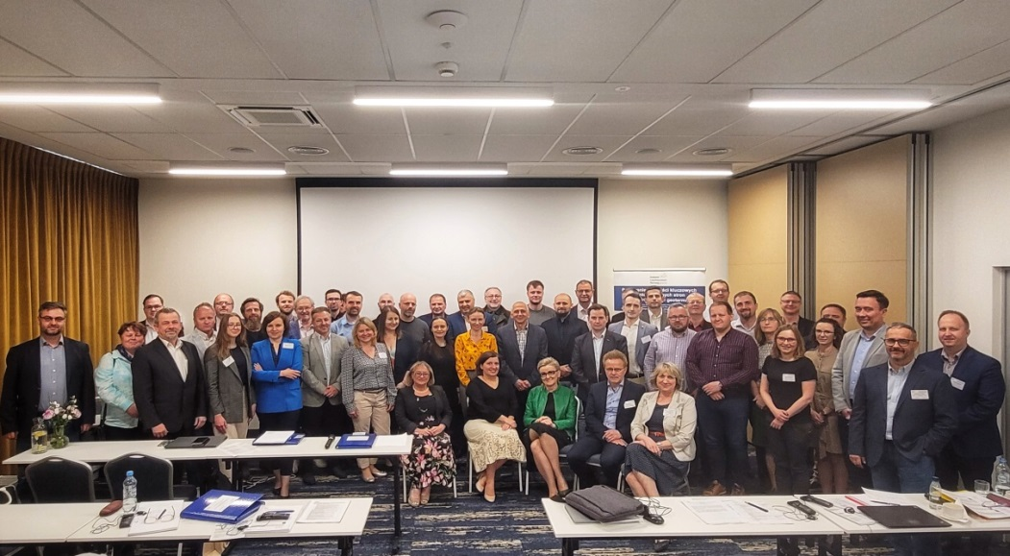
Participants of Training Activities (photo by A. Kasztelewicz)

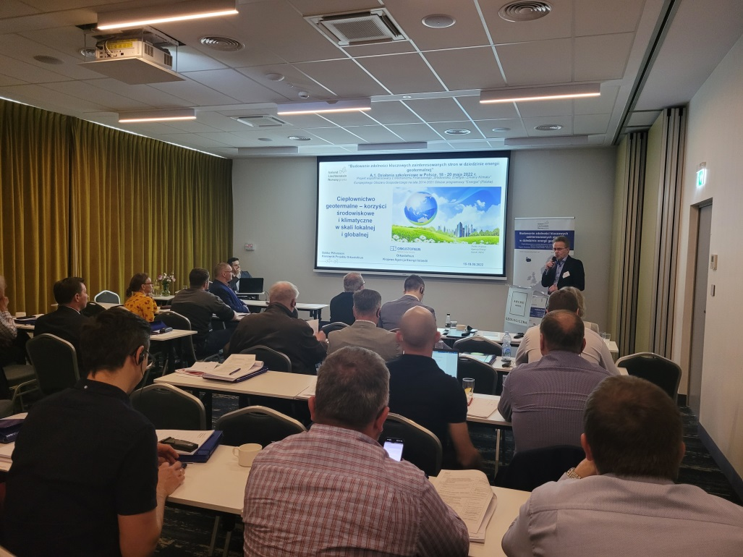
During one of the lecture sessions (photo by A. Kasztelewicz)

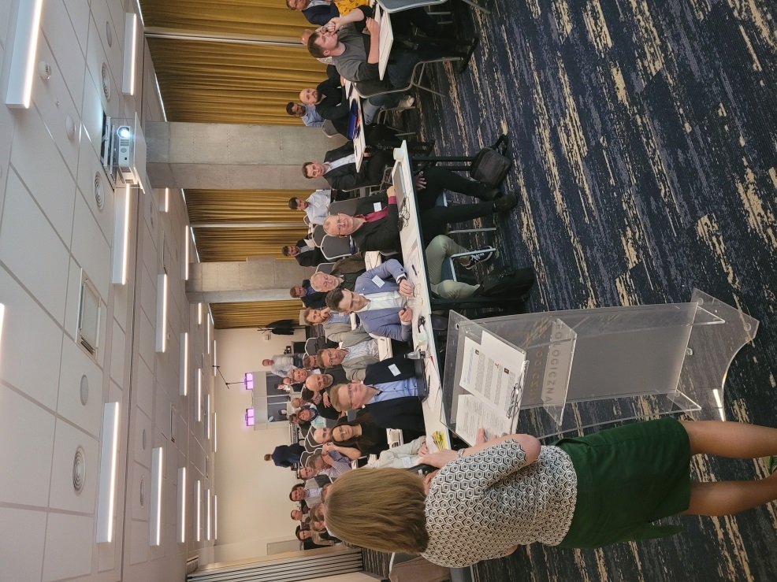
During one of the lecture sessions (photo by A. Kasztelewicz)

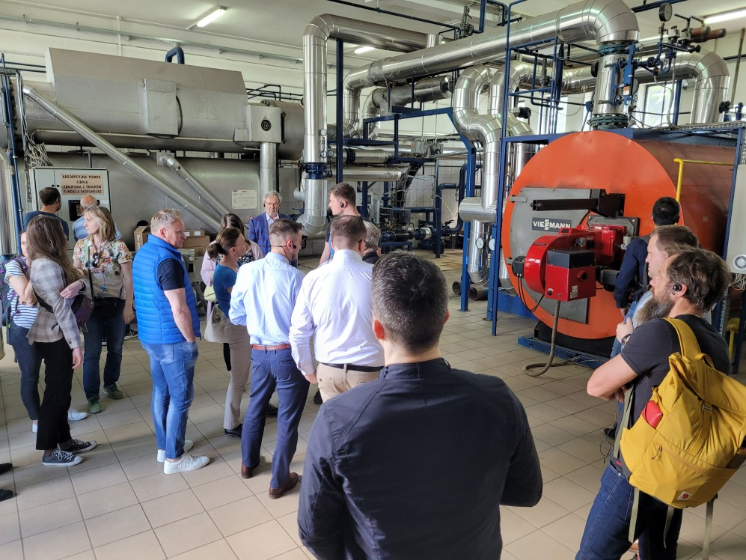
Technical visits - geothermal heating plant in Mszczonów (photo by A. Kasztelewicz)

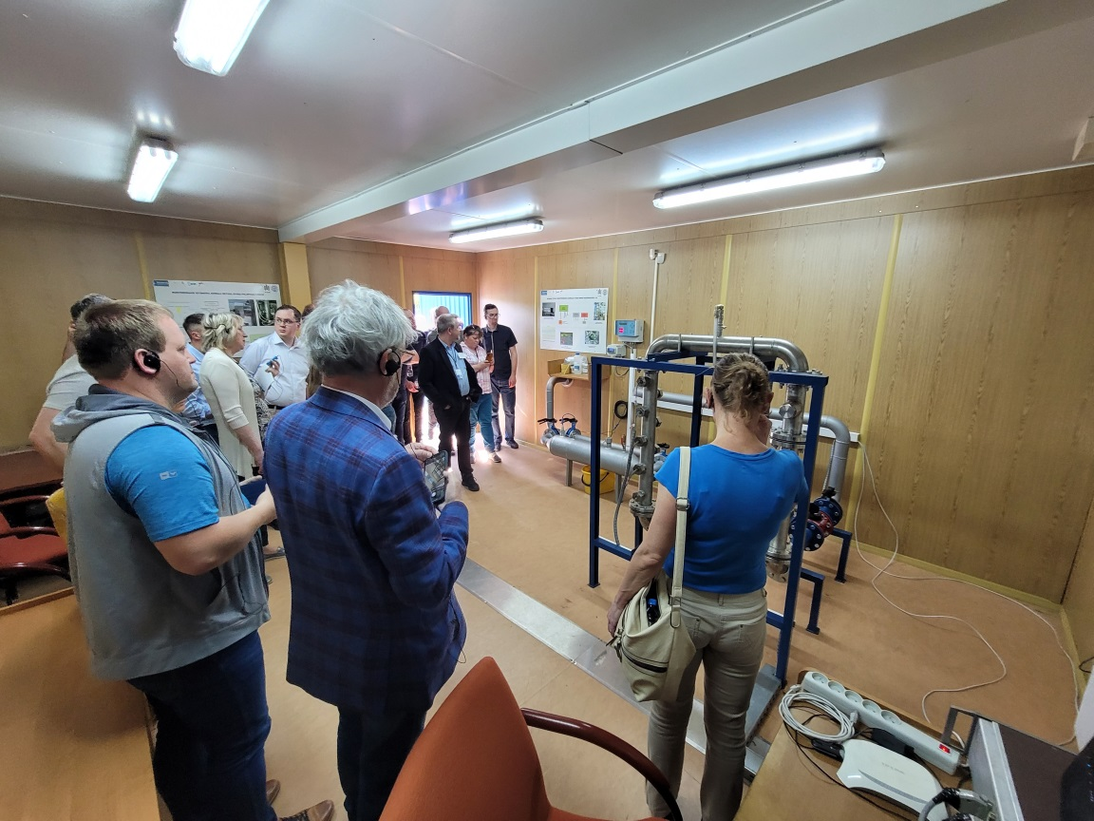
Technical visits - corrosion monitoring station at the Mszczonów IG-1 geothermal well
(photo by A. Kasztelewicz)

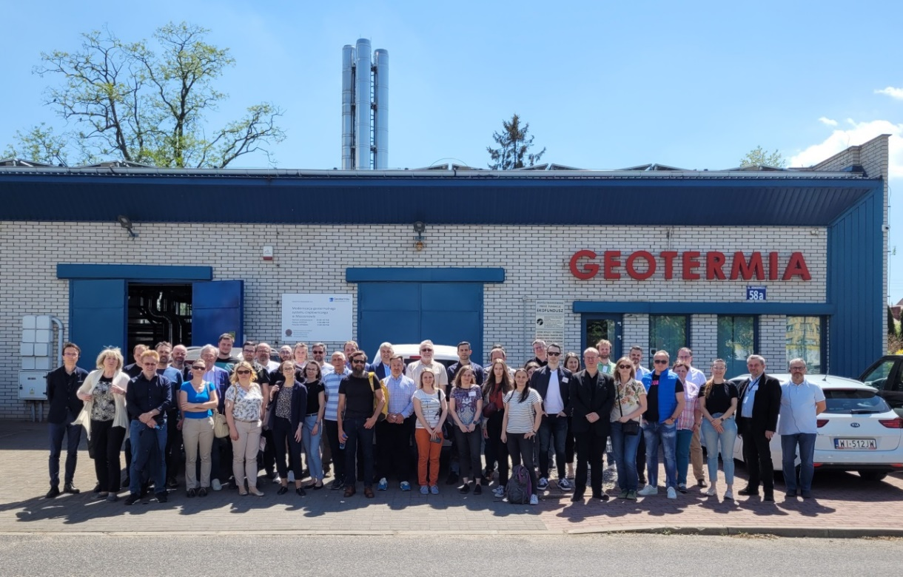
Participants of technical visits in front of the geothermal heating plant in Mszczonów
(photo by A. Kasztelewicz)

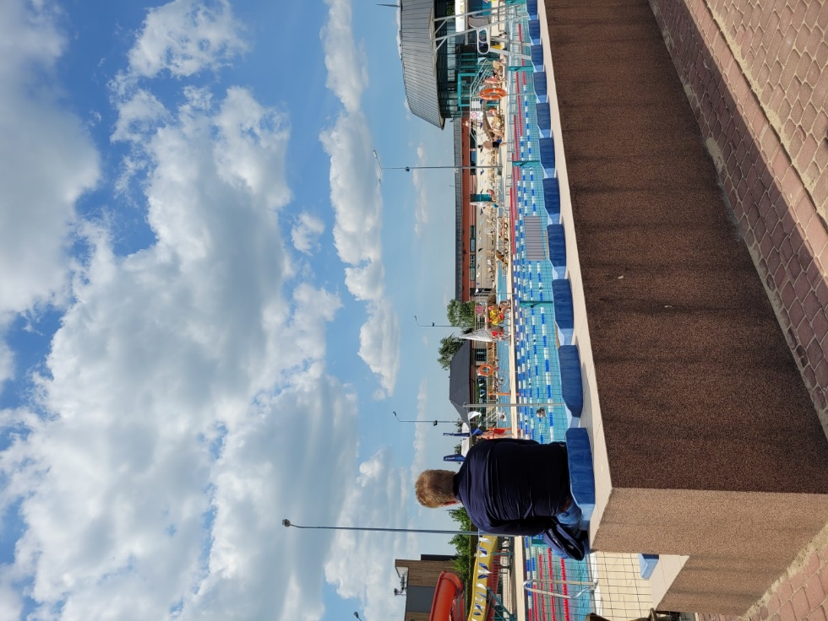
Technical visit - Termy Mszczonów (photo by A. Kasztelewicz)

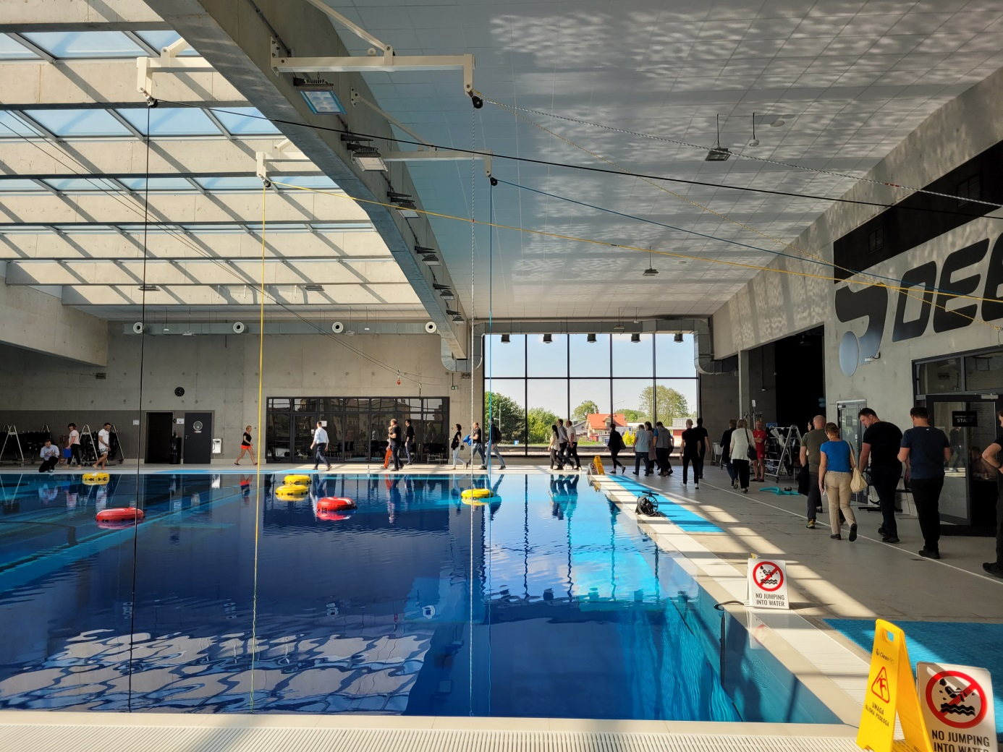
Technical visits - Deepspot in Mszczonów. Below the water level, there is an almost 47-meter depth of water heated with geothermal heat (photo by A. Kasztelewicz)

